analysis and modeling of lithium flows in porous materials
J. Rudolph*, G. Miloshevsky
School of Nuclear Engineering, Purdue University, West Lafayette, Indiana 47907, USA
*e-mail: jrudolp@purdue.edu
Abstract – The [include 5-7 sentences]
1. INTRODUCTION
Liquid lithium (LL) walls have been identified as a potential solution to many of the engineering problems in a magnetic fusion reactor. The flowing liquid metal could provide heat removal, elimination of erosion via constant renewal of the wall, and possible stabilization of MHD modes. The NSTX-U experiments at the Princeton Plasma Physics Laboratory are planned for testing a pre-filled LL divertor system with capillary wicking channels for supply of lithium from an internal reservoir [ref.]. However, the erosion of the LL surface can be induced by plasma flow or Lorentz forces that may lead to its instability and undesirable effects such as waving, de-wetting, and lithium droplet formation. [add more from slide 3, also look in the literature]
[Add on the description of experiments from slides 23 and 24]
[Add a final paragraph on our motivation and goals of research from slide 4]

2. THEORETICAL AND COMPUTATIONAL MODELS
In this study, both linear stability analysis and computational modeling have been used to study the coupled liquid metal-plasma flows [refs]. The linear stability analysis includes thermal effects, viscous forces, and the porosity of the material through which the LL flows. The expression for the relative velocity of the viscous instability in a porous material is derived. The porous media is described by porosity and permeability coefficients. Using harmonic normal modes in the linearized Navier-Stock equations, we derive the following expression for the relative velocity 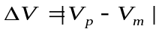 of the viscous K-H instability in the porous media
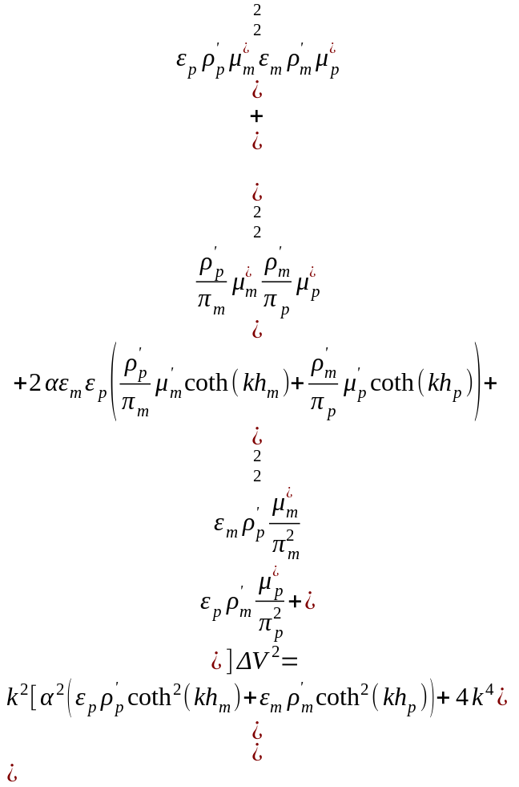 (1)
where 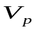, 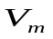, 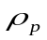, 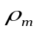 denote the velocity and mass density of plasma and melt, 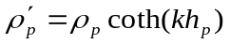, 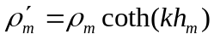, 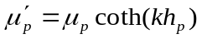, 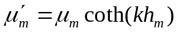, 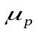, 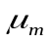, 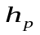, 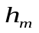 are the viscosity and thickness of plasma and melt, 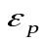 and 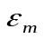 are plasma and melt porosities, 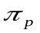 and 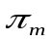 are permeabilities of plasma and melt in the porous media, 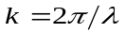 is the wave number associated with small disturbances 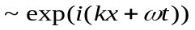, 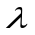 is the wavelength, 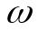 is the frequency, 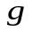 is the gravity constant, 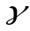 is the interfacial surface tension, 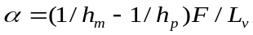 is the coefficient of heat transfer, 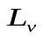 is the latent heat of evaporation, 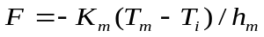 is the equilibrium heat flux, and 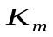 is the heat conduction coefficient. This viscous potential flow analysis was applied to the plasma-lithium melt system shown in Fig. 1. [check slides 5-6 if anything is missing] [everything in the slides appears to be already be there, but I reworded some things at the beginning] The following parameters are used. [add parameters from slide 7] [I will add these this weekend, as I will need Microsoft Word to format them consistently and I can only use LibreOffice Writer on my office computer]

The computational model is developed for treating the LL flow with a free surface in a porous material, as well as the coupled LL-plasma flow under the influence of an external magnetic field [refs.]. The model is based on the interFoam solver included in the OpenFOAM CFD toolbox, which uses the volume of fluid (VOF) method to track the LL/gas phases and the interfaces between them. The VOF method supplements the Navier-Stokes equations with a transport equation for the relative volume of LL in each cell, with this “volume fraction” field used to calculate the mean fluid properties in each cell and the surface tension forces at the LL-plasma interface [ref.].
We have expanded the model by implementing the effects of thermal conduction, medium porosity, and magnetic fields into the interFoam solver. The magnetic effects are implemented using the ideal magnetic induction and divergence equations, with the resulting Lorentz (JxB) force and Joule heating terms added to the momentum and heat conduction equations, respectively. The porosity of the medium is implemented as a body force in the momentum equation according to the Darcy-Forchheimer equation, which describes the resistance to flow of the porous medium.
The set-up of the two-dimensional CFD domain is shown in Fig. 2. The domain is divided into three zones: the lower zone as a porous material saturated by the flowing LL, the middle zone as a nonporous medium containing either argon (Ar) gas or LL flow, and the upper zone as a nonporous material saturated by the flowing Ar gas. [Should we discuss the dimensions of each region? I’m not clear on whether the thickness of the lower zone is adjusted to match the LL inlet thickness, or kept constant as the LL thickness is varied above/below the zone boundary] Simulations are run in the domain for various LL/gas velocities, LL layer thicknesses, and magnetic field strength/orientations to investi
[describe setup using slide 14]

3. LINEAR STABILITY ANALYSIS
[describe what you see in Figs. 3 and 4, also use slides 8 and 9, and slide 10 summarizing the results]

4. VoF-MHD MODELING
[describe the results shown in Figs. 5-7, use slides 16, 18, and 20, and slide 21 summarizing the CFD results]

5. CONCLUSIONS
The theoretical analysis and computational modeling of the LL surface and the interaction between the plasma and lithium including transition regimes and disruption events are performed. The results provide insights into the understanding of the physical mechanisms of lithium waving, splashing, and droplet formation. [add more]

The results of this research advance the understanding of physical processes that may limit, prevent or eliminate the LL losses from PFCs in fusion devices.

FIGURE CAPTIONS

Fig. 1. Sketch of the plasma-LM system.

Fig. 2. Set up of 2D CFD domain.

Fig. 3. Effects of porosity of medium with very large permeability for LM on stabilization of surface waves.

Fig. 4. Effects of permeability of LM in the medium with porosity ε_{m} = 0.1 on stabilization of surface waves.

Fig. 5. Snapshots of LM flow of different thickness with velocity 2 m/s at 1 s.

Fig. 6. Snapshots of 4 mm LM flow with 1 and 2 m/s in porous media at various times.

Fig. 7. Snapshots of Ar plasma flow with various speed over 6 mm LM flowing with 2 m/s.

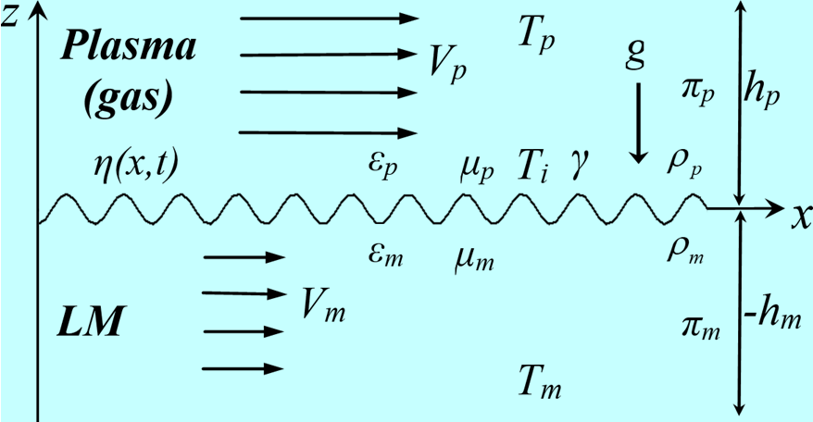

Fig. 1

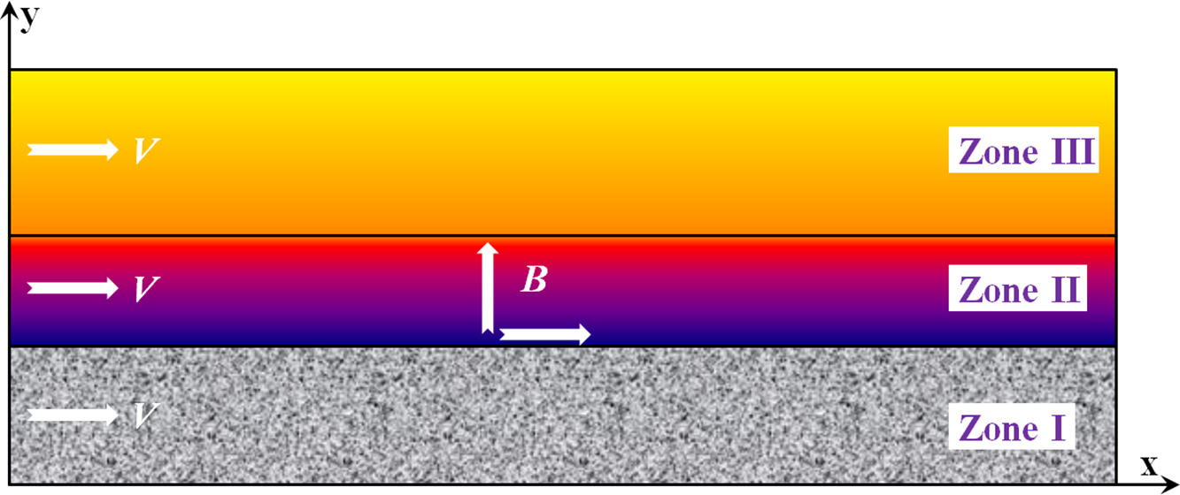

Fig. 2

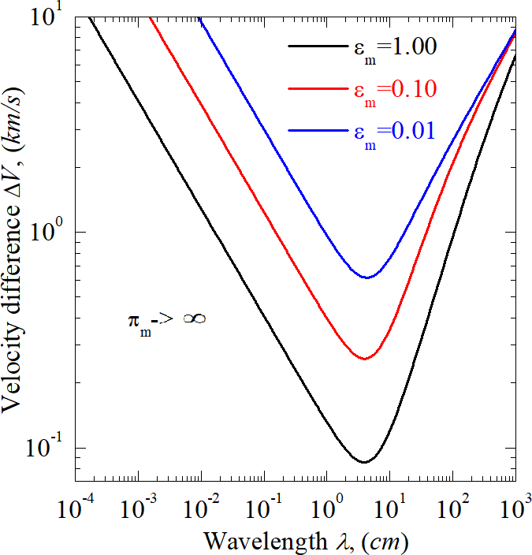

Fig. 3

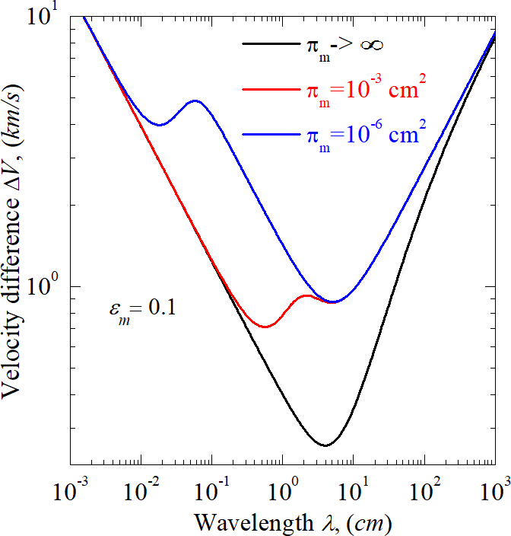

Fig. 4

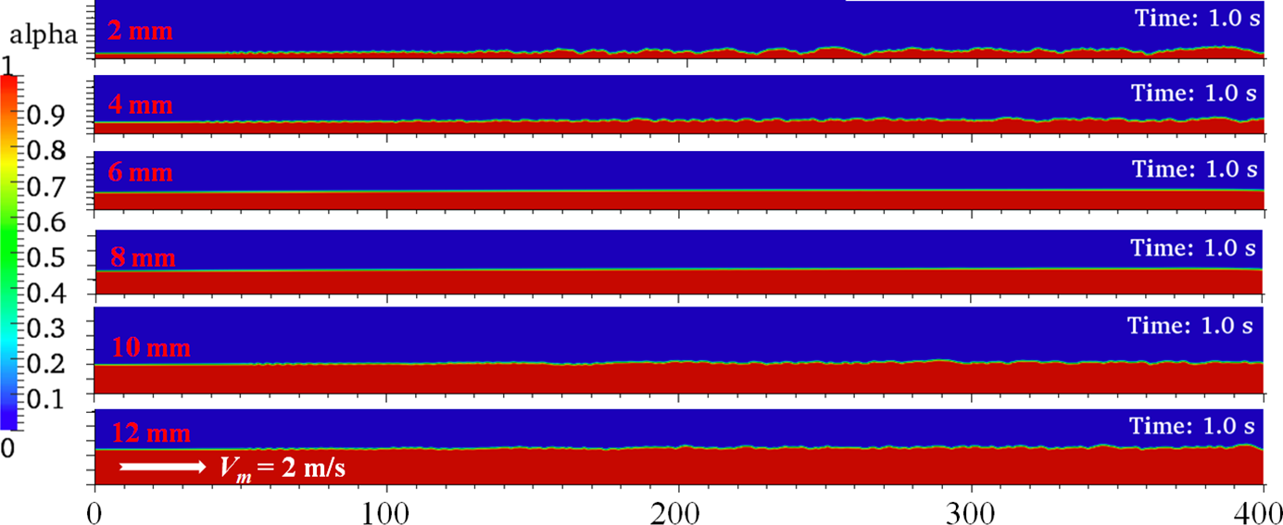

Fig. 5

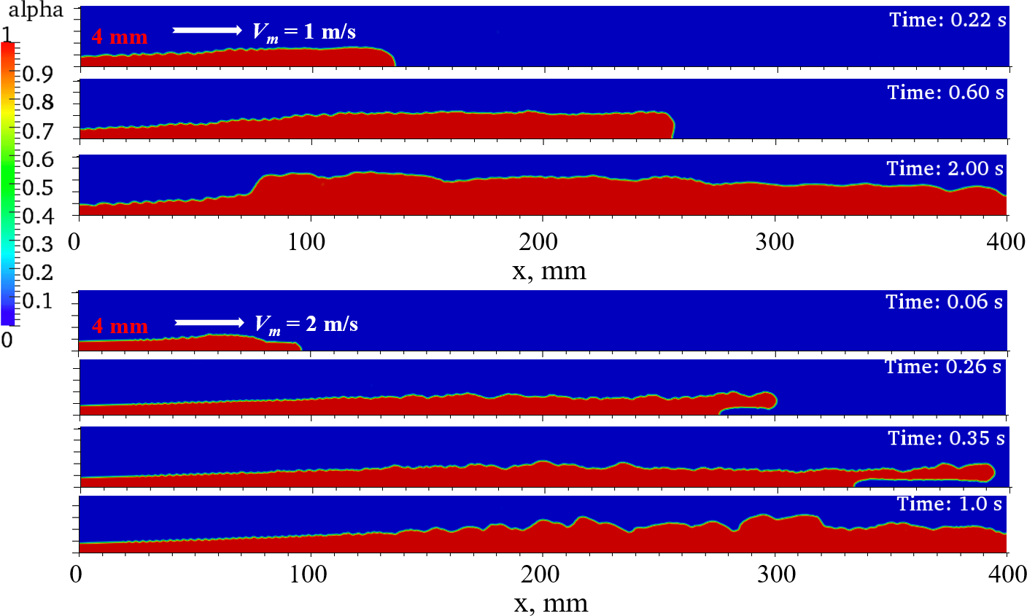

Fig. 6

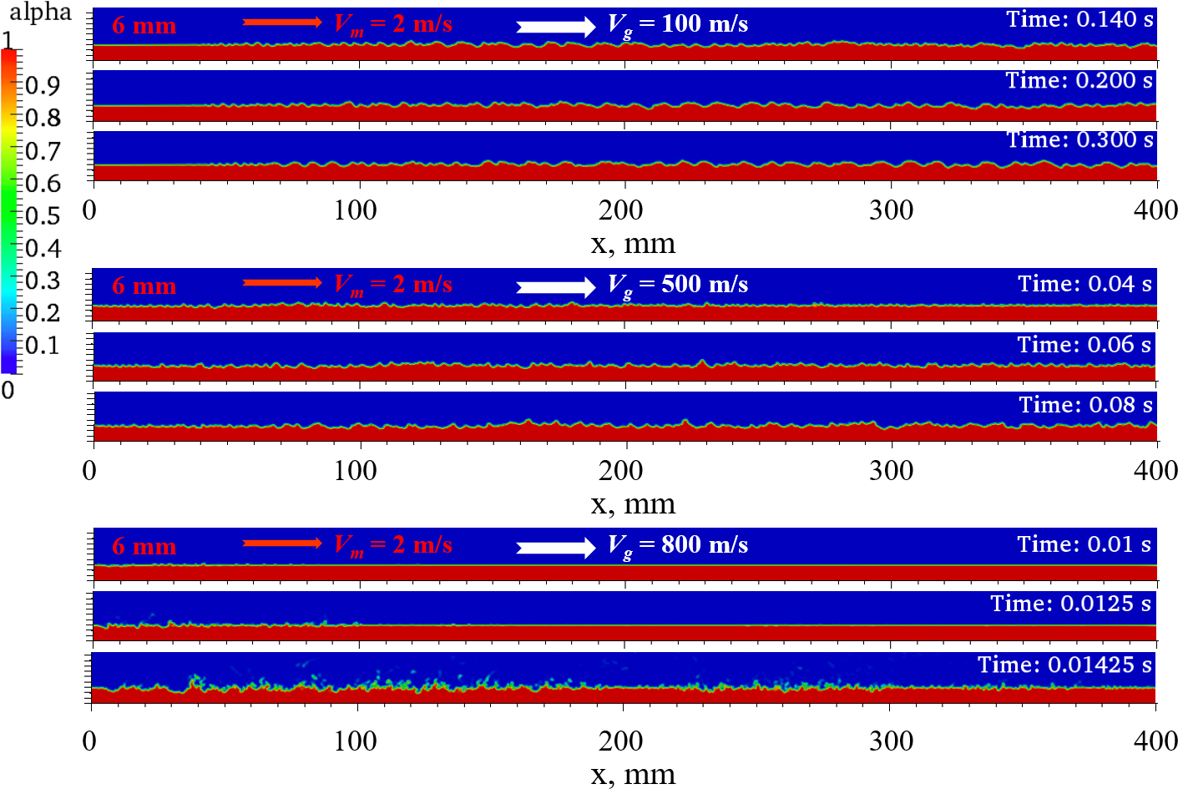

Fig. 7

REFERENCES

